**ASSIGNMENT 5**

**Problem Statement:**

1.Java program to implement the concept of importing classes from user defined package and creating packages.

**CODE:**

import AddPack.*;

import java.util.*;

class trial{

public static void main(String args[]){

AddPack.add t = new AddPack.add();

t.addition();

}

}

**Package contents :**

package AddPack;

import java.util.*;

public class add {

public void addition(){

Scanner n = new Scanner(System.in);

System.out.print("Enter 1st number : ");

int num1 = n.nextInt();

System.out.print("Enter 2nd number : ");

int num2 = n.nextInt();

System.out.println("Sum is : " + (num1 + num2));

}

}

**OUTPUT:**

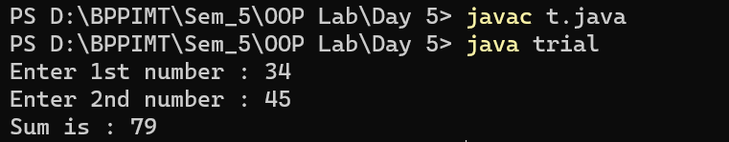

2.  Write a java program to explain the use of access specifiers - Public, Protected, Default, Private

**CODE:**

package AllPack;

import AddPack.*;

import java.util.*;

class publicAccess{

static void division(){

Scanner n = new Scanner(System.in);

System.out.print("Enter 1st number : ");

int num1 = n.nextInt();

System.out.print("Enter 2nd number : ");

int num2 = n.nextInt();

System.out.println("Quotient is : " + (num1 / num2));

}

public static void main(String args[]){

AddPack.add t = new AddPack.add();

t.addition();

}

}

// protected methods are accessible within the same package or subclasses in different packages

class protectedAccess extends AddPack.add{

public static void main(String[] args) {

protectedAccess pro = new protectedAccess();

pro.subtraction();

}

}

// methods with default access are accessible within the same package

class DefaultAccess{

public static void main(String[] args) {

publicAccess t = new publicAccess();

t.division();

}

}

class PrivateAccess{

private void product(){

Scanner n = new Scanner(System.in);

System.out.print("Enter 1st number : ");

int num1 = n.nextInt();

System.out.print("Enter 2nd number : ");

int num2 = n.nextInt();

System.out.println("Product is : " + (num1 * num2));

}

public static void main(String[] args) {

System.out.println("As the method 'product' is private it can only be accessible from this class");

PrivateAccess t = new PrivateAccess();

t.product();

}

}

**Package Contents:**

package AddPack;

import java.util.*;

public class add {

public void addition(){

Scanner n = new Scanner(System.in);

System.out.print("Enter 1st number : ");

int num1 = n.nextInt();

System.out.print("Enter 2nd number : ");

int num2 = n.nextInt();

System.out.println("Sum is : " + (num1 + num2));

}

protected void subtraction(){

Scanner n = new Scanner(System.in);

System.out.print("Enter 1st number : ");

int num1 = n.nextInt();

System.out.print("Enter 2nd number : ");

int num2 = n.nextInt();

System.out.println("Difference is : " + (num1 - num2));

}

}

**OUTPUT:**

